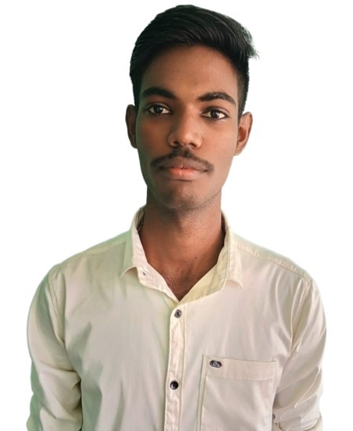

Satheeshkumar T

**Phone** : 8124402004

**Email :** [sathisatheesh2843@gmail.com](mailto:sathisatheesh2843@gmail.com)

**LinkedIn** : https:/[/w](http://www.linkedin.com/in/satheeshkumar-t-a58104249/)w[w.linkedin.com/in/satheeshkumar-t-a58104249/](http://www.linkedin.com/in/satheeshkumar-t-a58104249/)

**GitHub :** https://github.com/satheesh2843

**Address** : 71, Arasamarathottam, Karattupalayam, Erode Dist., Tamil Nadu.



## CAREER OBJECTIVE:

To look forward for an opportunity to apply my knowledge with group of motivated individuals who wish to work towards the advancement of the company and its goals.

## ACADEMIC BACKGROUND:

|  |  |  |  |
| --- | --- | --- | --- |
| **Qualification** | **Passing Year** | **Institutions** | **Marks in CGPA/percentage** |
| B. E. **ELECTRONICS AND COMMUNICATION ENGINEERING** | 2025  (pursuing) | Karpagam Academy of Higher Education | 8.07  (up to 4 semester) |
| HSC | 2021 | Komarsamy Gounder Matriculation Higher Secondary School | 86.46 |
| SSLC | 2019 | Komarsamy Gounder Matriculation Higher Secondary School | 80.2 |

**PROJECT:**

## INTERNSHIP:

* Undergone 15 days internship at Pantech e Learning where I learnt Python language**.**
* Undergone 30 days internship at Vault of Code where I learnt Java language**.**

**CERTIFICATES:**

* Startup Idea from Galgotias University in Noida.
* Introduction to Cyber Security from Infosys.
* Decision Trees using Python from Infosys.
* Introduction to Python from Infosys.
* Introduction of Artificial Intelligence from Infosys.
* Molecular Basis of Inheritance.
* Data Analysis with Python from IBM.
* Excel Basics for Data Analysis from IBM.
* Introduction to C from Solo learn.

## WORKSHOPS:

* Embedded System using Arduino UNO.
* Mobile Services Workshop
* Advances in Optical Communication organized by IIT Madras

**AREA OF INTEREST:**

* Programming
* Web development

## TECHNICAL SKILLS:

* C.
* Java (pursuing).
* Python (pursuing).
* MS Office.
* HTML.
* CSS.
* SQL.

# STRENGTH:

* Excellent Communication (Tamil and English).
* Effective Planning.
* Adaptability to Work Independently and Collaborate in a Team

# Declaration:

I hereby declare that the information stated above is true to the best of my knowledge.

## [Satheeshkumar T]